Why Are Cave Animals Colorless? Tyrosinase-Positive Albinism in Cavefish
William R. Jeffery
Department of Biology, University of Maryland, College Park, MD. 20742 U. S. A.
ABSTRACT
Many cave-adapted animals appear to be colorless due to loss of body pigmentation. The developmental mechanisms involved in this evolutionary change are unknown. We have studied pigment cell regression in the teleost Astyanax mexicanus, a single species consisting of a pigmented epigean form (surface fish) and a de-pigmented hypogean form (cavefish). During vertebrate development pigment cells differentiate from migratory neural crest cells, which are derived from surface epithelium at the border of the prospective epidermis and neural plate. As the neural plate becomes the neural tube, neural crest cells leave the epithelium, migrate along specific pathways through the interior of the embryo, and eventually differentiate into many different adult derivatives, including the three types of teleost pigment cells: melanophores (black cells), xanthophores (yellow or orange cells), and iridophores (iridescent cells). All three pigment cell types are present in surface fish. In contrast, cavefish have xanthophores and iridophores but lack melanophores. The deficiency in melanophores could be caused by (1) the development of fewer neural crest cells, (2) the failure of neural crest cells to migrate correctly, (3) the failure of neural crest cells to become melanoblasts, the immediate precursors of melanophores, (4) the unscheduled death of melanophores or their precursors, or (5) the failure of melanoblasts to differentiate into melanophores. We have used several different experimental approaches to test these hypotheses. First, Dil (1,1’-dioctadecyl-3,3,3’,3’-tetramethylindocarbocyanine tetramethylindocarbocyanine perchlorate), a lipophilic cell surface marker, was injected into the region where neural crest cells originate and labeled cells were followed during surface fish and cavefish embryonic development. The results showed that cavefish embryos produce as many neural crest cells as surface fish embryos and that these cells migrate properly, discounting hypotheses (1) and (2). Second, analysis by TUNEL, a cell death indicator, showed that most cavefish melanophore precursors survive through development, discounting hypothesis (4). Third, the presence of melanoblasts in cavefish was determined by detection of cells expressing tyrosinase, the enzyme that converts L-DOPA to melanin. The results showed the presence of large numbers of tyrosinase-positive melanoblasts in cavefish embryos and adults. Thus, cavefish neural crest cells are able to develop into melanoblasts, which does not support hypothesis (3). Finally, we tested the ability of cavefish melanoblasts to convert L-tyrosine, the precursor of L-DOPA, into L-DOPA and melanin, a process that normally occurs during their differentiation into melanophores. The results showed that cavefish melanoblasts are unable to convert L-tyrosine to L-DOPA, indicating a deficiency in L-tyrosine uptake or utilization. Therefore, we conclude that cavefish lose body pigmentation because their melanoblasts fail to differentiate into melanophores (hypothesis 5). Cavefish melanoblasts could be diverted into other neural crest-derived cell types, which may confer an adaptive advantage in the cave environment.

INTRODUCTION
The amazing phenotypes of cave-adapted animals, including the regression of eyes and pigmentation, have fascinated biologists since the time of Darwin [1]. We study the evolutionary regression of eyes and pigment cells in the teleost Astyanax mexicanus, one of the few cave-adapted vertebrates that exhibit both surface–dwelling (epigean) and conspecific cave-dwelling (hypogean) forms [2]. The epigean form of Astyanax (surface fish) has large eyes and pigmentation, whereas the hypogean form (cavefish) has lost or substantially reduced its eyes and pigmentation (Figure 1). Actually, 29 different cavefish populations have been identified in the Sierra de El Abra region of northeastern Mexico [2], and there is evidence that some of these populations may have evolved cave specific phenotypes independently [3]. Astyanax surface fish and cavefish diverged from a common ancestor about 10,000 to 100,000 years ago when the progenitors of the hypogean form were trapped in limestone caves [2]. The advantage of the Astyanax system is that the epigean and hypogean forms can be cultivated in the laboratory, where they spawn frequently and are amenable to many types of genetic, developmental, and molecular experiments [4].

Although we are beginning to understand the developmental and evolutionary basis for eye degeneration in cavefish [5-7], much less is known about how and why body pigmentation has disappeared. There are three types of pigment cells in teleosts: iridescent iridophores, yellow or orange xanthrophores, and black melanophores. Cavefish have retained iridophores and xanthrophores but melanophores are lacking or present in greatly reduced numbers. Different Asytanax cavefish populations have evolved various degrees of melanophore loss: some populations (e. g. cavefish from the Pachón Cave) contain completely depigmented fishes, whereas others (e. g. cavefish from the Chica, Los Sabinos, Curva, and Tinaja Caves) contain fishes with reduced numbers of melanophores. In contrast to many evolutionary changes in development, which are controlled by multiple genes, a recessive mutation in a single gene is responsible for albinism in Pachón cavefish [8]

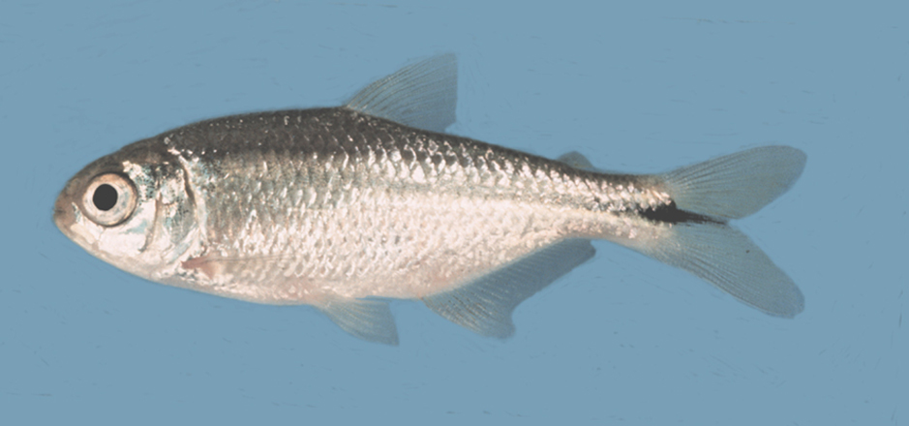

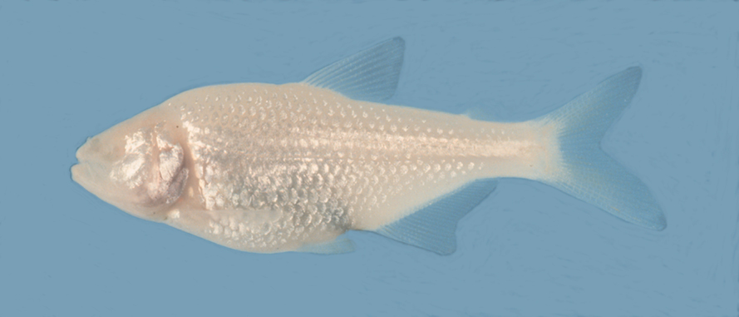

Figure 1. Top: Eyed and pigmented Astyanax surface fish. Bottom: Eyeless and colorless Astyanax cavefish.

All pigment cells arise from the neural crest during vertebrate embryogenesis [9]. Neural crest cells are originally derived from surface epithelium at the border of the prospective epidermis and neural plate. As the neural plate rolls into the neural tube and the latter and begins to differentiate into the central nervous system, neural crest cells leave the epithelium and migrate along specific pathways through the interior of the embryo, eventually differentiating into many different adult derivatives, including sensory and sympathetic ganglia, the visceral nervous system, glia, cranial cartilage and bone, and parts of the eye, ear, teeth, and endocrine organs. Obviously, the regression of cavefish melanophores cannot be attributed to the complete loss of neural crest cells because their absence would be lethal. Instead, the loss or reduction in pigmentation could be caused by the absence of a subset of cavefish neural crest cells devoted to melanophore differentiation, by the failure of neural crest cells to migrate correctly into the epidermis, or by the inability of neural crest cells to complete their differentiation into melanophores. In addition, as exemplified by cavefish embryonic lens cells [5], it is possible that melanophores or their progenitor cells are formed in cavefish embryos but subsequently die, resulting in a colorless adult.

Here we describe the results of experiments that address the mechanism of melanophore loss in Astyanax cavefish embryos. We show that cavefish contain abundant neural crest cells, which migrate properly but do not completely differentiate into functional melanophores because they are unable to convert L-tyrosine to L-DOPA, the precursor of black melanin pigment. Thus, Astyanax cavefish exhibit the same type of albinism that accounts for most human albinisms.

RESULTS

Migratory Neural Crest Cells in Cavefish

To determine whether Pachón cavefish have migratory neural crest cells, we used cell tracing, immunological, and tissue culture methods [10]. First, the lipophilic cell surface marker Dil (1,1’-dioctadecyl-3,3,3’,3’-tetramethylindocarbocyanine tetramethylindocarbocyanine perchlorate) was injected into the neural tube, the region where neural crest cells originate, and labeled cells were followed during surface fish and Pachón cavefish embryonic development. We found that cavefish embryos produce as many DiI-positive neural crest cells as surface fish embryos and that these cells migrate properly into the epidermis, where they would normally form melanophores. Second, cavefish embryos were stained with the monoclonal antibody HNK-1, which detects a cell surface lipoprotein that is restricted to migrating neural crest cells in vertebrate embryos [9]. We observed about the same number of HNK-1 positive cells in surface fish and cavefish embryos. Third, the neural tube was dissected from Pachón cavefish embryos and cultured in vitro. We saw cells migrating away from neural tubes in culture that resemble neural crest-derived pigment cells in their morphological and biochemical properties (see below). The results indicate that cavefish embryos produce migratory neural crest cells in similar numbers to their surface fish counterparts.

Cavefish Neural Crest Cells Do Not Show Massive Death

To determine whether the absence of melanophores in cavefish can be attributed to programmed cell death (apoptosis), we assayed cavefish embryos for apoptosis by TUNEL, which detects fragmented nuclear DNA molecules typical of apoptotic cells [5]. As described previously [5], we saw apoptotic cells specifically in the lens and sporadic episodes of cell death throughout the cavefish embryo. However, we were unable to observe more than a few dying neural crest cells in cavefish embryos, which was the same level of programmed cell death as observed in surface fish embryos. These results suggest that melanophores or their progenitor cells do not show massive apoptosis during cavefish embryogenesis.

Tyrosinase-Positive Melanoblasts in Cavefish

Melanophore differentiation involves the initial formation of colorless melanoblasts, which subsequently synthesize black melanin pigment and become functional melanophores. Melanin pigment is synthesized in the melanosome, a membrane bound organelle that can move from place to place in the cytoplasm and is responsible for physiological changes in the intensity of body coloration. The biochemical steps involved in melanin synthesis are well known. First, the essential amino acid L-tyrosine is transported from the cytoplasm into the melanosome, where it is converted to L-DOPA by the multifunctional enzyme tyrosinase. Next, L-DOPA is converted into melanin within the melanosome by a series of enzymatic reactions, the first of which is also catalyzed by tyrosinase. Most of the subsequent reactions in the pathway are spontaneous.

Oculocutaneous albinism 1 (OCA1), one type of human albinism, is caused by mutations in the tyrosinase gene [11]. Therefore, we asked whether cavefish contain functional tyrosinase. Adding exogenous L-DOPA to fixed specimens and measuring the deposition of black melanin pigment granules was used to assay tyrosinase activity. The results showed that Pachón, Chica, Los Sabinos, Tinaja, and Curva cavefish exhibit active tyrosinase in cells resembling the precursors of melanoblasts in their morphology and location within the embryo (Figure 2). Tyrosinase positive melanoblasts were also observed in adult cavefish. These results indicate that the inability to synthesize melanin is not caused by an inactive or non-functional tyrosinase but must be due to a block in the melanogenic pathway upstream of the tyrosinase dependent steps.
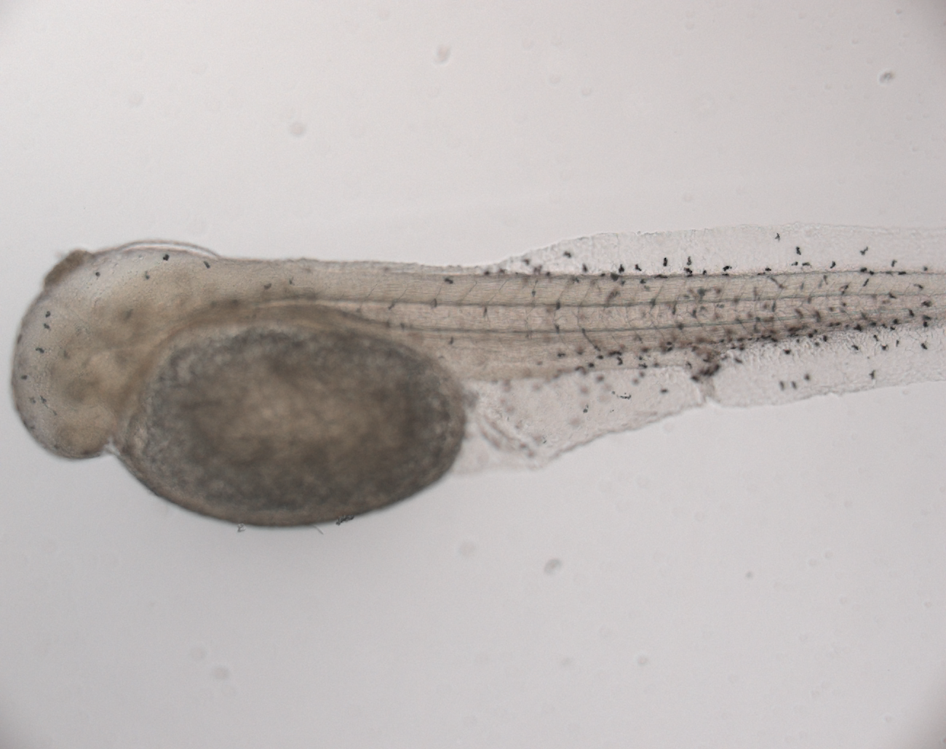

Figure 2. A 30 hr old Pachón cavefish embryo assayed for tyrosinase activity by adding exogenous L-DOPA to form black melanin in tyrosinase-positive cells.

Cavefish Are Unable to Convert L-tyrosine into L-DOPA

The step in melanin synthesis immediately before the L-DOPA dependent reactions is the conversion of L-tyrosine to L-DOPA, which is also catalyzed by tyrosinase. Cavefish must have L-tyrosine itself because it is required for protein synthesis. However, the ability of L-tyrosine to be converted to L-DOPA could be affected in cavefish. We investigated this possibility by providing exogenous L-tyrosine to fixed specimens and assaying for melanin deposition. If cavefish were able to convert L-tyrosine to L-DOPA we would expect to see black pigment deposition in the melanosomes of the same cells that have active tyrosinase. However, even after incubation with an excess of L-tyrosine, melanin deposition could not be detected in any cavefish population we have studied. The results show that cavefish melanoblasts cannot convert L-tyrosine to melanin, although they contain active tyrosinase, suggesting that melanogenesis is blocked at the step in which cytoplasmic L-tyrosine substrate becomes accessible to the enzyme within the melanosome.

Tyrosinase-positive Melanoblasts Are Derived From the Cavefish Neural Crest

Are the tyrosinase-positive cells we have discovered derived from the cavefish neural crest? We addressed this question in two different ways [10]. First, we injected the neural tube of Pachón cavefish embryos with DiI, allowed the DiI labeled cells to migrate into the peripheral regions of the embryo, and then fixed the injected embryos and assayed them for tyrosinase activity. We observed a subset of the DiI labeled cells that also showed tyrosinase activity. Second, migratory cells that originated from isolated cavefish neural tubes in culture were assayed for tyrosinase activity. We discovered that these cells are tyrosinase positive. The results support the conclusion that tyrosinase-positive melanoblasts are derived from the cavefish neural crest.

Discussion

We conclude that cavefish neural crest cells migrate properly into the epidermis but the melanoblasts they produce cannot convert L-tyrosine to L-DOPA by active tyrosinase and thus do not completely differentiate into melanophores. The reason that L-DOPA cannot be produced from L-tyrosine by active tyrosinase is unknown, although it is likely to be related to a deficiency in transport of the amino acid substrate into the melanosome. Whatever the reason for this deficiency, it has evolved in all of the cavefish populations we have examined, including those that have been derived independently from a surface fish ancestor [3], suggesting extreme biochemical convergence in the evolution of albinism among Astyanax cavefish.

In lacking the ability to convert L-tyrosine to L-DOPA, albinitic cavefish populations resemble the most common type of albinism in humans: oculocutaneous albinism type II (OCA2), a form of tyrosinase-positive albinism [12]. OCA2 tyrosinase-positive albinism is caused by mutations in the oca2 gene, the human homologue of the mouse pink-eyed dilution (p) gene, which encodes a 100 kDa integral membrane protein of the melanosome [13]. Although its precise function is unclear, the OCA2/P protein has been proposed either to facilitate L-tyrosine transport into the melanosome or to generate a proton flux regulating melanosome pH, which is important in melanin synthesis.

As mentioned earlier, tyrosinase-positive albinism is controlled by a recessive mutation in a single cavefish gene [8]. Recently, QTL analysis has indicated that mutations in the oca2 gene are also responsible for tyrosinase-positive albinism in several different Astyanax cavefish populations [14]. Thus, these studies have uncovered molecular convergence between a cavefish trait induced by the dark cave environment and a human syndrome: OCA2 albinism. Cavefish eye degeneration is caused by increased bilateral separation of the eye primordia mediated by Hedgehog signals emanating from the anterior embryonic midline [7]. Interestingly, widely set eyes, similar to the cavefish embryonic eye phenotype, characterize another human syndrome, hypertelorism. The implication is that mutations leading to these phenotypes occur frequently in animal populations, including cavefish and humans. Defects in pigment and eye development that result from these mutations are effectively neutral in the dark cave environment, and thus can be passed from generation to generation without dire consequences.

Although we now have increased insight into the genetic and biochemical basis for cavefish albinism, several important questions remain to be answered that should be a focus for further research on the loss of pigmentation in cave animals. First, do all cave animals show OCA2 tyrosinase-positive albinism or as in humans have different types of albinism, including those equivalent to human OCA1 tyrosinase-negative albinism and OCA3 and OCA4 tyrosinase-positive albinism [12], evolved in the cave environment? Second, assuming that OCA2 tyrosinase-positive albinism is widespread in cave animals, why has this particular step in the melanogenic pathway been selected for modification during repeated episodes of regressive evolution? One possible explanation is that the oca2 gene is particularly sensitive to mutation [15], perhaps because of its large size (345 kb in humans), chromosomal location, or exclusive function in melanogeneis. Another intriguing possibility is that oca2 may be a pleiotropic gene with multiple effects in development. Accordingly, OCA2/P could function at a pivotal fork in the melanophore development pathway in which a loss of function mutation downregulating pigmentation may reciprocally enhance an unknown adaptive trait(s), which is beneficial to survival in the cave environment.

REFERENCES

1. Culver, D. (1982). Cave Life. Evolution and Ecology. Harvard Press, Cambridge.
2. Mitchell, R. W., Russell, W. H., and W. R. Elliot (1977). Mexican eyeless characin fishes, genus Astyanax: Environment, distribution, and evolution. Spec. Publ. Mus. Texas Tech Univ. 12: 1-89.
3. Dowling, T. E., Martasian, D. P., and W. R. Jeffery. (2002). Evidence for multiple genetic lineages with similar eyeless phenotypes in the blind cavefish, Astyanax mexicanus. Mol. Biol. Evol. 19: 446-455.
4. Jeffery, W. R. (2001). Cavefish as a model system in evolutionary developmental biology. Dev. Biol. 231: 1-12.
5. Yamamoto, Y., and W. R. Jeffery (2000). Central role for the lens in cave fish eye degeneration. Science 289: 631-633.
6. Yamamoto, Y, Stock, D. W., and W. R. Jeffery (2004). Hedgehog signalling controls eye degeneration in blind cavefish. Nature 431: 844-847.
7. Jeffery, W. R. (2005). Adaptive evolution of eye degeneration in the Mexican blind cavefish. J. Hered. 96: 185-196.
8. Sadoglu, P. (1957). Mendelian inheritance in hybrids between the Mexican blind fish and their overground ancestors. Verh. Dtsch. Zool. Ges. 1957: 432-439.
9. Hall, B. K. (1999). The Neural Crest in Development and Evolution. Springer, New York.
10. McCauley, D. W., Hixon, E., and W. R. Jeffery. (2004). Evolution of pigment cell regression in the cavefish Astyanax: A late step in melanogenesis. Evol. Dev. 6: 209-218.
11. King, R. A., Pietsch, J., Fryer, J. P., Savage, S., Brott, M. J., Russell-Eggitt, I., Summers, C. G., and W. S. Oetting (2003). Tyrosinase gene mutations in oculocutaneous albinism 1 (OCA1): definition of the phenotype. Hum. Genet. 113: 502-513.
12. Oetting, W. S., and R. A. King (1999). Molecular basis of albinism: mutations and polymorphisms of pigmentation genes associated with albinism. Hum. Mutat. 13, 99-115.
13. Rinchik, E. M., Bultman, S. J., Horsthemke, B., Lee, S. T., Strunk, K. M., Spritz, Avidano, K. M., Jong, M. T., and R. D. Nicholls (1993). Nature 361: 72-76.
14. Protas, M., E., Hersey, C., Kochanek, D., Zhou, Y., Wilkens, H., Jeffery, W. R., Zon, L. T., Borowsky, R., and C. J. Tabin (2005). Genetic analysis of cavefish reveals molecular convergence in the evolution of albinism. (in submission).
15. Oetting, W. S., Garrett, S. S., Brott, M., and R. A. King (2005). P gene mutations associated with oculocutaneous albinism type II (OCA2). Human. Mutat. 25: 323.

